**Economic Complexity and Global Supply Chain Resilience: Insights through Advanced Data Visualization**

Final Project  
INFOSCI 301

Prof. Luyao Zhang

Yifei Wang

1. **Background and motivation**

Understanding the interplay between economic complexity and global supply chain resilience is essential for addressing global economic disparities and fostering sustainable growth. Economic complexity metrics, which measure the sophistication and diversity of a nation's economy, offer invaluable insights into developmental trajectories and trade patterns. Supply chain resilience, a vital consideration in today's globalized economy, reveals how disruptions propagate, disproportionately impacting developing nations and exacerbating global inequality (Chakraborty et al., 2024). Data visualization plays a pivotal role in unpacking the multifaceted relationships between these domains. Through advanced visual tools, it is possible to uncover patterns, anomalies, and connections that traditional analysis might overlook. Such insights are invaluable for policymakers, businesses, and researchers aiming to achieve sustainable and inclusive growth.

One visualization that inspired this project is the Economic Complexity Map from the [Atlas of Economic Complexity](https://atlas.hks.harvard.edu/). This interactive tool displays trade data, highlighting the complexity and diversity of exports by country. **Figure 1** illustrates how this tool visualizes the export composition of China in 2022, providing clear insights into the nation’s trade patterns and economic diversity. Users can explore temporal trends, identify trade dependencies, and assess the relative sophistication of different economies. The Atlas shows how dynamic and multidimensional visualizations can communicate complex economic data effectively. It demonstrates the potential of visual tools to bridge the gap between academic analysis and real-world applications. Building upon this foundation, the project integrates economic complexity and systemic risk data to generate multidimensional visualizations that enable a nuanced understanding of the relationships between economic structure and trade resilience.  
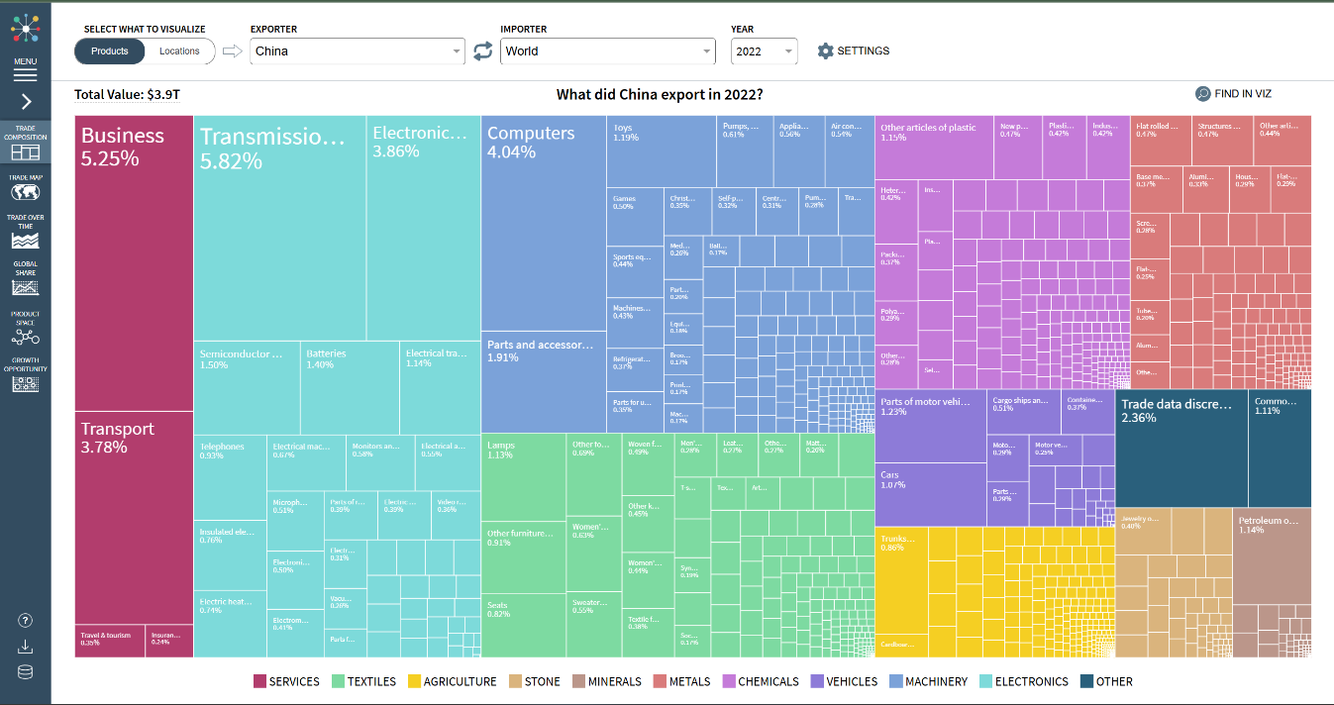

Figure 1 The visualization of China Trade composition, from The Atlas of Economic Complexity

1. **Research Questions**

This study explores the correlation between economic complexity and supply chain resilience, focusing on key questions that drive its objectives. First, how do patterns in economic complexity relate to supply chain resilience across global regions? This question examines whether higher economic sophistication correlates with reduced systemic risks and enhanced trade stability. Second, what systemic vulnerabilities exist within global trade networks, and how can these vulnerabilities be effectively visualized to enhance comprehension and inform mitigation strategies? By addressing this question, the study seeks to provide actionable insights for policymakers and businesses. Finally, how can interactive and real-time visualizations empower decision-makers to design sustainable development strategies? This aspect focuses on the practical utility of the visualizations in supporting informed policy and business decisions.

1. **Application Scenarios**

The findings of this research have significant implications across various domains. Policymakers can utilize the visualizations to identify regions with low economic complexity and heightened supply chain vulnerabilities, enabling targeted interventions to improve resilience and economic stability. For instance, governments may use the insights to design policies that promote diversification and technological advancement in vulnerable economies (Stojkoski et al., 2023). Businesses, on the other hand, can employ these tools to evaluate vulnerabilities within their supply chains. By identifying potential risks, companies can develop strategies to mitigate disruptions, ensuring continuity and competitiveness in the global market (Chakraborty et al., 2024). For example, adopting strategies from network analysis can highlight critical facilities whose disruptions could significantly impact supply chain resilience (Ghanadian & Ghanbartehrani, 2021). Research has highlighted that resilient supply chains reduce the economic costs of disruptions and are crucial for maintaining global trade stability (Baldwin & Freeman, 2022).Additionally, academics and researchers can benefit from leveraging this framework to extend investigations into economic complexity and systemic risk, fostering innovation in data-driven methodologies.

1. **Literature Review**

Machine learning (ML) has become an essential tool for analyzing complex economic phenomena. The application of ML to international trade and policy evaluation is demonstrated in studies like *Machine Learning in International Trade Research: Evaluating the Impact of Trade Agreements* (Breinlich et al., 2022), which uses ML techniques to uncover nuanced impacts of trade agreements. Additionally, ML applications in economic complexity, as reviewed by Gogas (2021), highlight its potential to identify patterns and predict outcomes in multidimensional datasets.

Advanced visualization tools have revolutionized interdisciplinary research, enabled the integration of diverse datasets and enhanced their interpretability. For example, the Atlas of Economic Complexity (HKS, 2024) employs interactive visualizations to communicate complex trade data effectively. Similarly, Applications of AI for Interdisciplinary Research (Gill, 2024) demonstrates how visualization can bridge gaps between disciplines, fostering collaborative innovation.

1. **Methodology**

This research employs a combination of advanced data visualization techniques and interdisciplinary analytical approaches to explore the relationship between economic complexity and supply chain resilience. The visualizations utilize principles such as marks and channels to represent various aspects of the data. For instance, economic complexity is depicted through the size of nodes, trade relationships are shown by the thickness of edges, and systemic risks are encoded using color gradients. These visual elements are integrated into spatial and network visualizations to map global trade flows, revealing key vulnerabilities and interdependencies.

Data integration is a cornerstone of this research. Economic complexity metrics are sourced from comprehensive datasets detailing global trade and technological outputs, while systemic risk data are derived from firm-level trade network datasets that highlight disruption cascades and vulnerabilities (Alves et al., 2022). By aligning these datasets along geographic, temporal, and sectoral dimensions, the study provides a holistic perspective on the interplay between economic sophistication and trade resilience. Recent developments in reconstructing national supply networks using telecommunication data also emphasize the role of real-time data in understanding economic resilience and systemic risks (Reisch et al., 2021).

To enhance the interpretability and utility of the visualizations, the study leverages advanced analytical tools. Machine learning algorithms are employed to cluster regions based on complexity and resilience metrics, uncovering hidden patterns and correlations. Interactive dashboards enable users to manipulate parameters such as trade volume and systemic risk intensity, facilitating dynamic exploration of policy impacts. Furthermore, immersive 3D visualizations are used to integrate spatial and network data, providing an intuitive understanding of global trade networks and their vulnerabilities. Recommendations for distributed manufacturing based on economic complexity and input-output analysis offer additional strategies for optimizing supply chain resilience (Pachot et al., 2021).

1. **地图

   描述已自动生成Results**

Figure 2 Visulization of Economic Complexity Index with Trade and Exposure Metrics

Initial observations from pilot explorations and simulations have provided valuable insights into the relationship between economic complexity and supply chain resilience. For example, in **Figure 2**, preliminary visualizations of global trade networks have revealed geographic regions where high economic complexity corresponds with lower systemic risk levels, particularly in advanced economies. In contrast, areas with low economic complexity, often in developing region, exhibit heightened vulnerabilities to supply chain disruptions. These findings highlight critical disparities in global trade resilience and emphasize the need for targeted policy measures to address these gaps (Breinlich et al., 2022).

The integration of spatial and network data has also demonstrated the utility of visualizations in identifying hidden interdependencies, offering a deeper understanding of global trade dynamics. The application of social network analysis to supply chains has further revealed potential areas for strengthening global trade networks (Ghanadian & Ghanbartehrani, 2021).

1. **Intellectual Merit and Practical Impacts**

This study makes significant contributions to the academic community by advancing the application of interdisciplinary visualization techniques in the analysis of global economic phenomena. By integrating economic, trade, and risk analysis with innovative visualization frameworks, it provides a novel approach to examining complex relationships that are often overlooked in traditional studies. The combination of spatial, temporal, and network data in a single visualization framework represents a breakthrough in data-driven research methodologies, offering a blueprint for future studies on economic complexity and supply chain resilience.

The practical implications of this research are equally substantial. Policymakers can leverage insights to design strategies that optimize economic development and resilience, addressing disparities and vulnerabilities in global trade networks. Businesses can use the findings to identify and address weaknesses in their supply chains, ensuring operational continuity and compliance with sustainability goals. The use of real-time telecommunication data for supply network reconstruction provides a new frontier for enhancing transparency and mitigating systemic risks (Reisch et al., 2021). By addressing critical challenges such as economic inequality, supply chain disruptions, and global trade imbalances, this research contributes to the broader goal of achieving inclusive and sustainable development.

1. **Supplementary Materials**

The GitHub repository for this project is organized to ensure clarity and accessibility. It includes directories for code, data, visualizations, and documentation. The README.md file provides detailed navigation instructions, embedded visualizations, and reflective commentary, ensuring that users can easily explore and understand the project’s components.

The other repository consist the interactive visualization product ‘Finalapp.py’, could be open in GitHub Codespace with requirement ‘requirements.txt’.

GitHub repository: <https://github.com/Yifei-unavailable/INFOSCI-301-Final-Project-Yifei-Wang.git>

GitHub repository for Interactive Visualization Product: <https://github.com/Yifei-unavailable/dash-yifei.git>

**Bibliography**

Alves, L. G. A., Mangioni, G., Rodrigues, F. A., Panzarasa, P., & Moreno, Y. (2022). The rise and fall of countries in the global value chains. *Scientific Reports*, *12*(1). https://doi.org/10.1038/s41598-022-12067-x

Baldwin, R., & Freeman, R. (2022). Risks and Global Supply Chains: What We Know and What We Need to Know. *Annual Review of Economics*, *14*(1), 153–180. https://doi.org/10.1146/annurev-economics-051420-113737

Breinlich, H., Corradi, V., Rocha, N., Ruta, M., Silva, S., & Zylkin, T. (2022, May). *Machine Learning in International Trade Research - Evaluating the Impact of Trade Agreements*. Ssrn.com. https://papers.ssrn.com/sol3/Delivery.cfm?abstractid=4121518

Chakraborty, A., Reisch, T., Diem, C., & Thurner, S. (2024). Inequality in economic shock exposures across the global firm-level supply network. *Nature Communications*, *15*(1). <https://doi.org/10.1038/s41467-024-46126-w>

Ghanadian, S. A., & Ghanbartehrani, S. (2021). Application of Social Network Analysis in Evaluating Risk and network resilience of Closed-Loop-Supply-Chain. ArXiv.org. https://arxiv.org/abs/2110.00652?utm_source=chatgpt.com

Gill, S. S. (2024). Applications of AI for Interdisciplinary Research. In *CRC Press eBooks*. Informa. https://doi.org/10.1201/9781003467199

Gogas, P., & Papadimitriou, T. (2021). Machine Learning in Economics and Finance. *Computational Economics*, *57*(1), 1–4. <https://doi.org/10.1007/s10614-021-10094-w>

Liu, Y., He, B., Hildebrandt, M., Buchner, M., Inzko, D., Wernert, R., Weigel, E., Beyer, D., Berbalk, M., & Tresp, V. (2023). A Knowledge Graph Perspective on Supply Chain Resilience. ArXiv.org. <https://arxiv.org/abs/2305.08506?utm_source=chatgpt.com>

Pachot, A., Albouy-Kissi, A., Albouy-Kissi, B., & Chausse, F. (2021). Decision support system for distributed manufacturing based on input-output analysis and economic complexity. ArXiv.org. <https://arxiv.org/abs/2201.00694?utm_source=chatgpt.com>

Reisch, T., Heiler, G., Diem, C., & Thurner, S. (2021). Inferring supply networks from mobile phone data to estimate the resilience of a national economy. ArXiv.org. https://arxiv.org/abs/2110.05625?utm_source=chatgpt.com

Stojkoski, V., Koch, P., & Hidalgo, C. A. (2023). Multidimensional economic complexity and inclusive green growth. *Communications Earth & Environment*, *4*(1), 1–12. https://doi.org/10.1038/s43247-023-00770-0

*The Atlas of Economic Complexity by @HarvardGrwthLab*. (2024). Harvard.edu. https://atlas.hks.harvard.edu/